**FILE CREATION TASK**

**Task Description :**

1. Create a directory called ""my_folder"", navigate into it, and create a file named ""my_file.txt"" with some text. Then, create another file named ""another_file.txt"" with some text. Concatenate the content of ""another_file.txt"" to ""my_file.txt"" and display the updated content. Finally, list all files and directories in the current directory.

**Step By step execution :**

**Command :** mkdir -p my_folder

→ created a directory “my_folder”

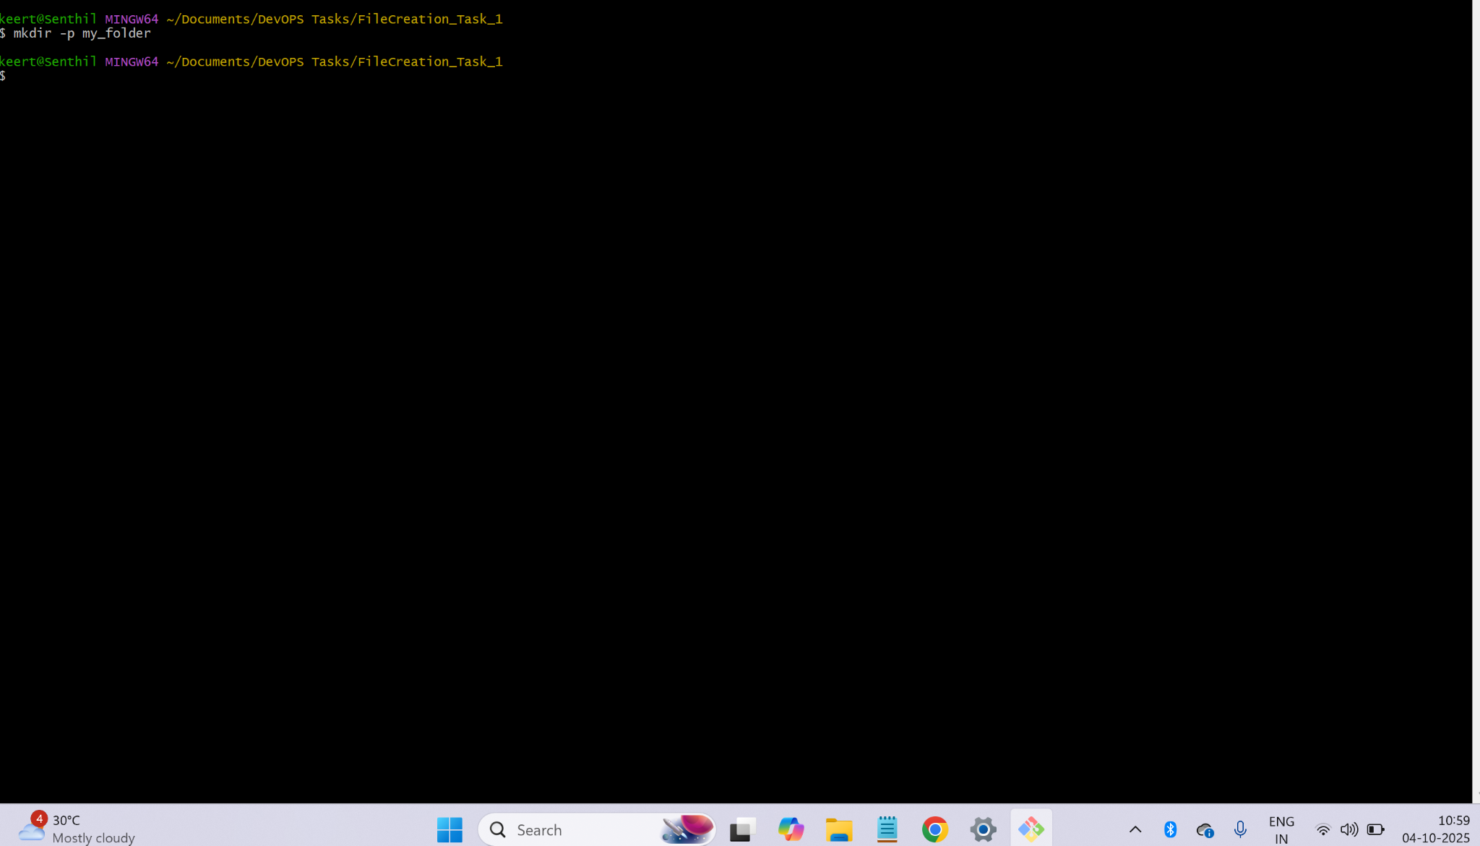

**Output :**

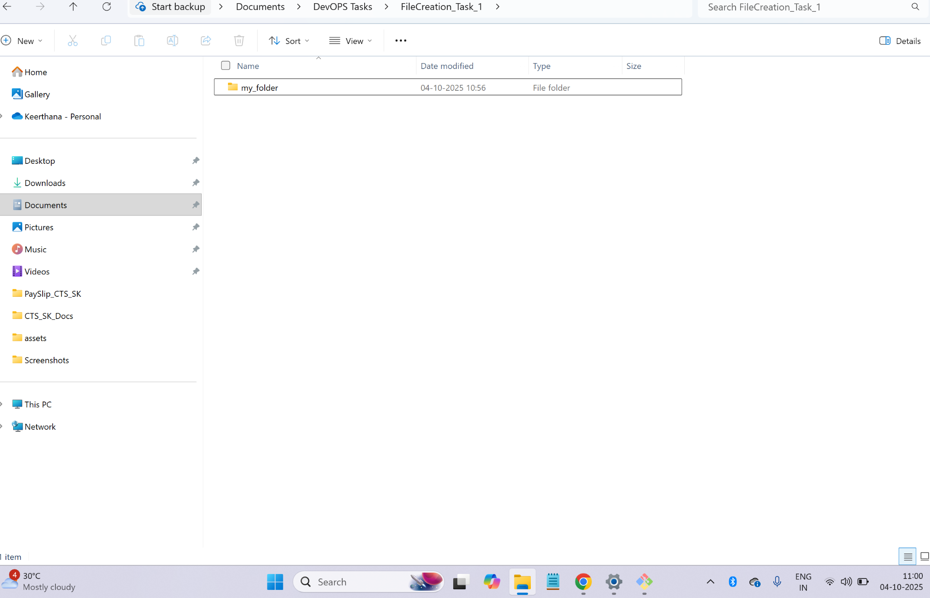

**Command :** cd my_folder

→ changed directory to created new folder my_folder

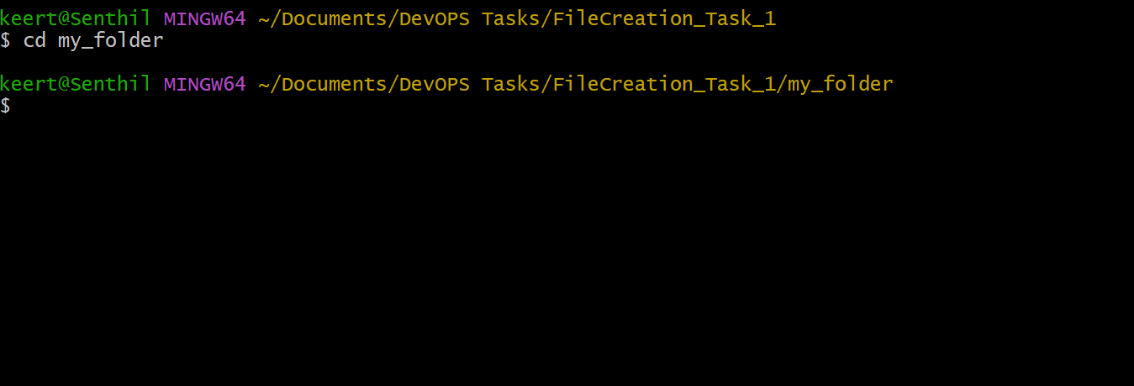

**Command :** → echo "Ths is the first line in my_file.txt" > my_file.txt

→ created a file “my_file.txt” with content inside it “Ths is the first line in my_file.txt"

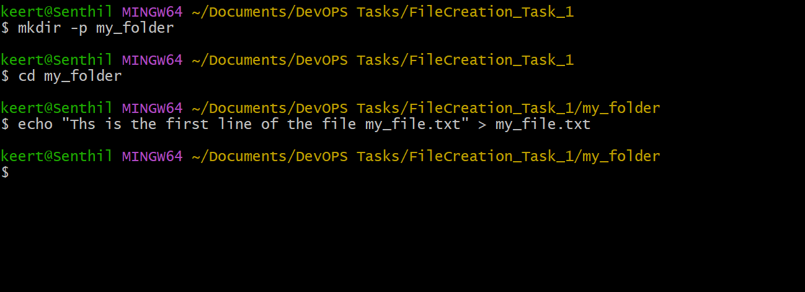

**Output :**

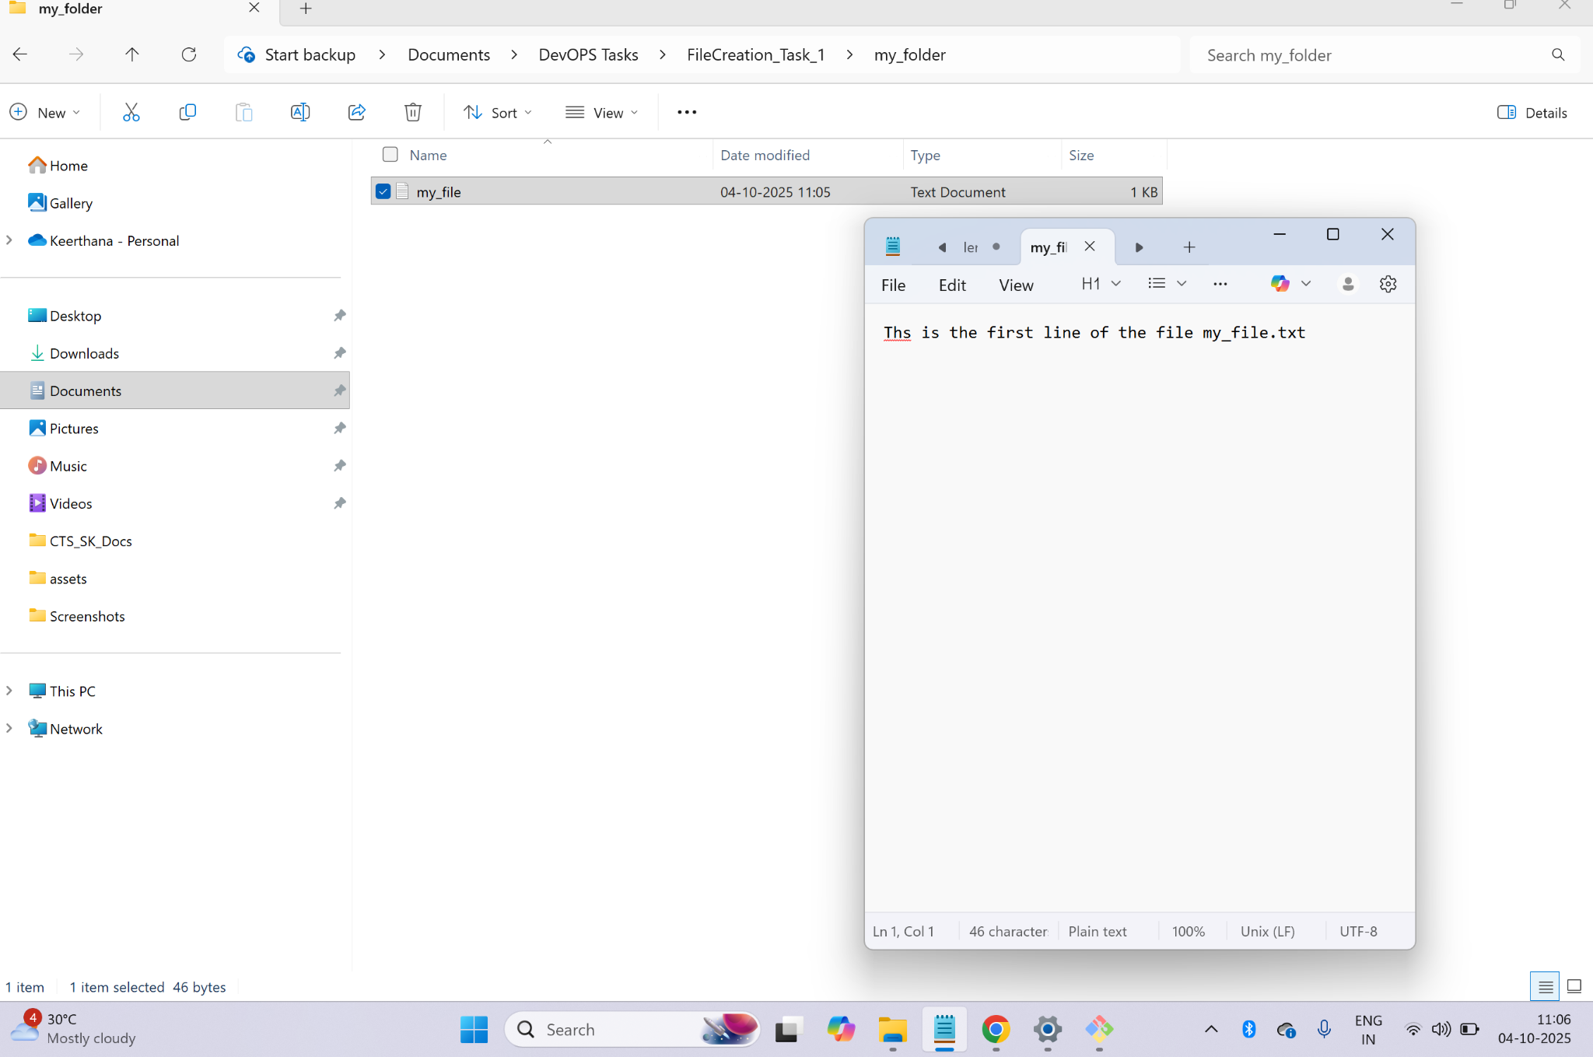

**Command :** → echo "This is the content from another file another_file.txt" > another_file.txt

→ created file called “another_file.txt” with text inside it "This is the content from another file another_file.txt"

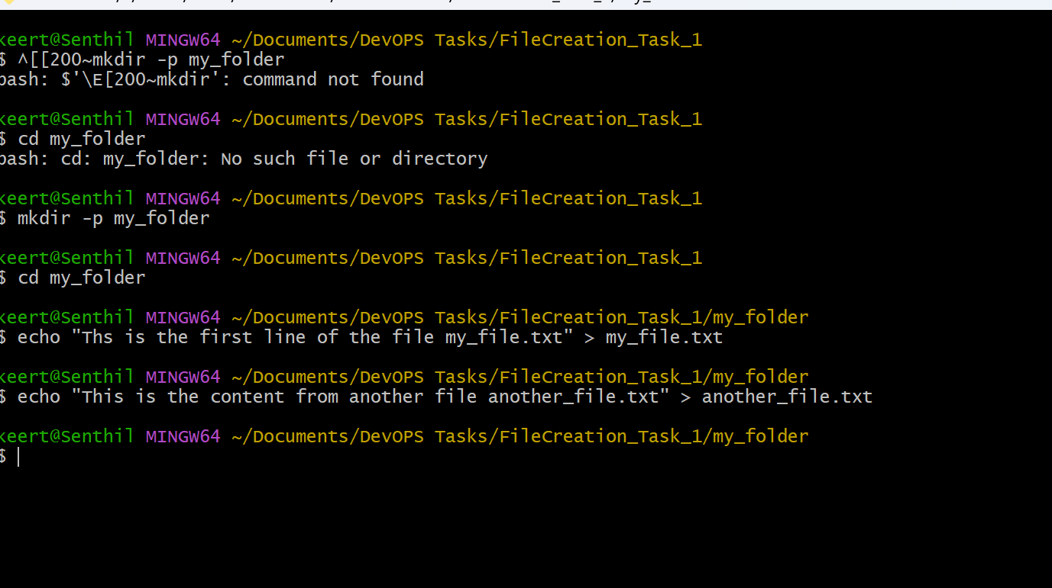

**Output:**

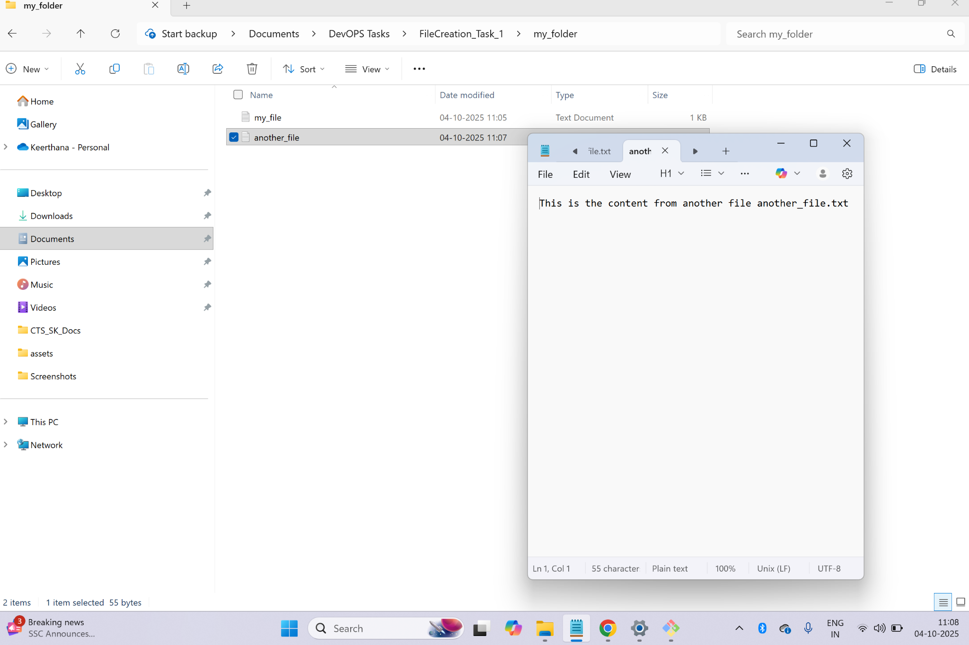

**Command :**

cat another_file.txt >> my_file.txt

cat my_file.txt

→ Concatenate the content of “another_file.txt” into the “my_file.txt” file.

→ Then display the updated file content

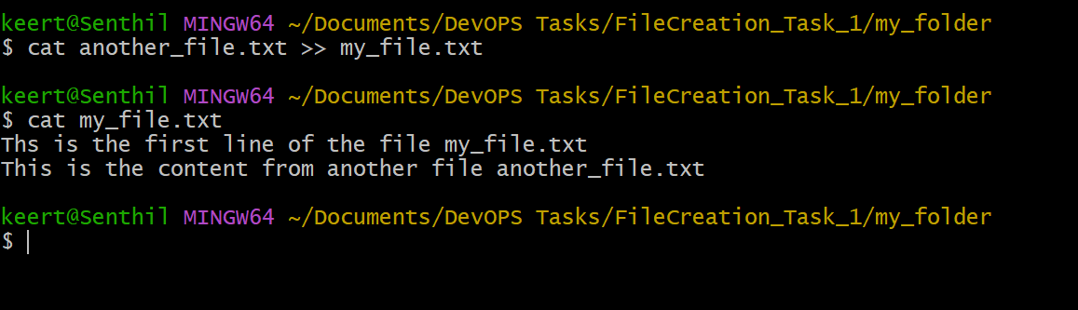

**Output :**

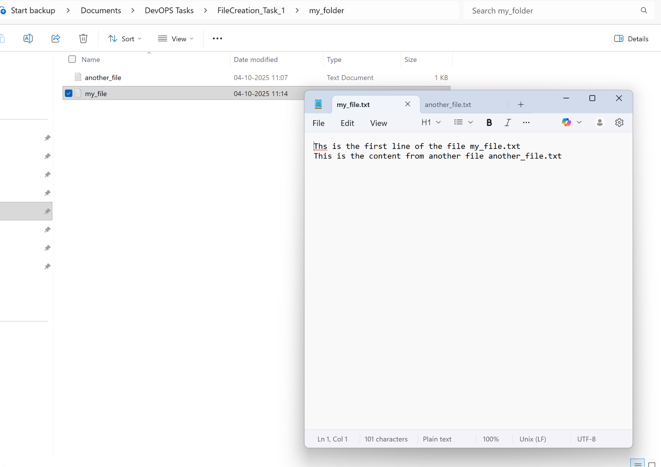

**Command :** ls - la

→list all files and directories in the current directory.

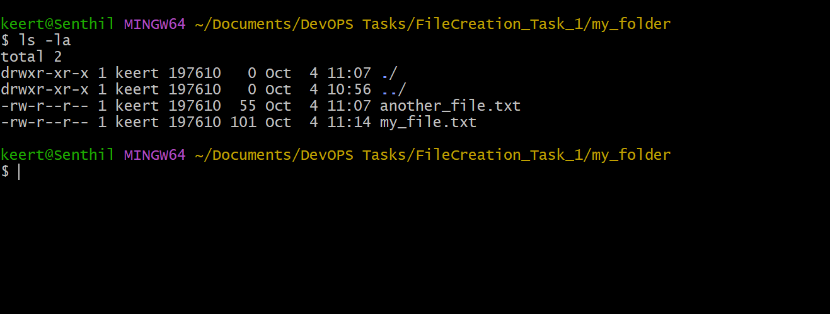

**===================================================================**

**Task 2:**

1. Create 20 files with .txt extensions and rename the first 5 files to .yml extension and print the latest created top 5 files among the total no of files".

**Step 1 :** Create 20 .txt files with a tiny line inside each

**Cmd :**

for i in {1..20}; do

echo "This is file $i" > "file${i}.txt"

done

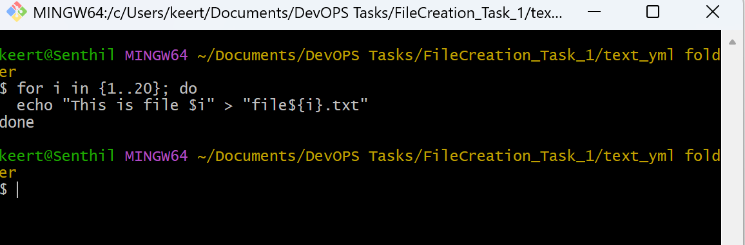

Output :

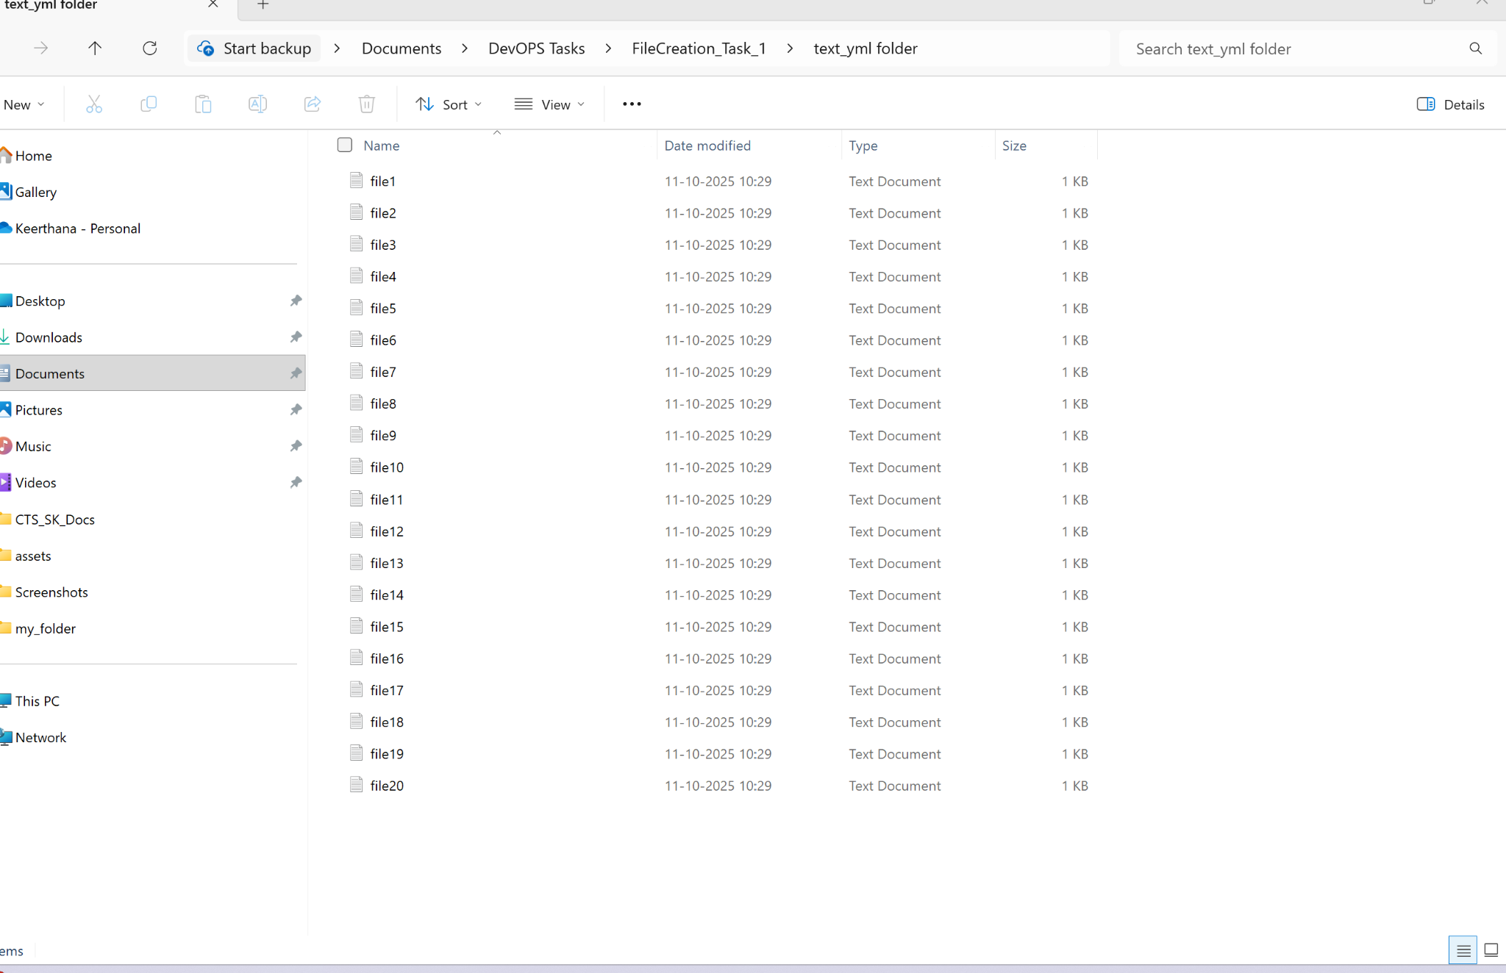

**Step 2** : Renaming first five files to .yml extension

**CMD :**

for i in {1..5}; do

mv "file${i}.txt" "file${i}.yml"

done

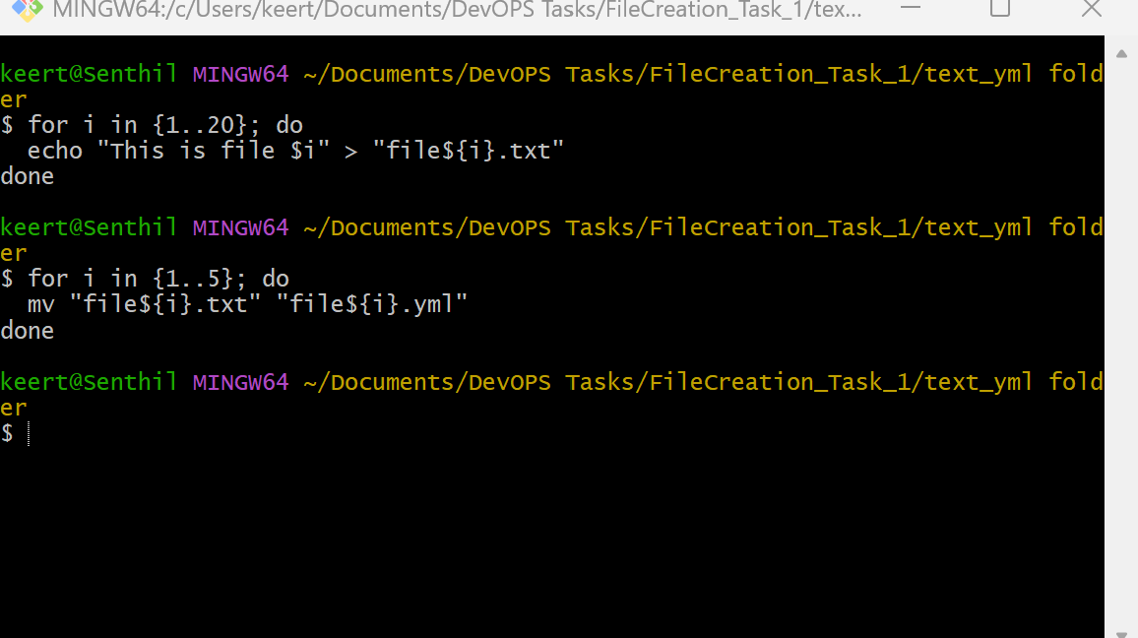

Output :

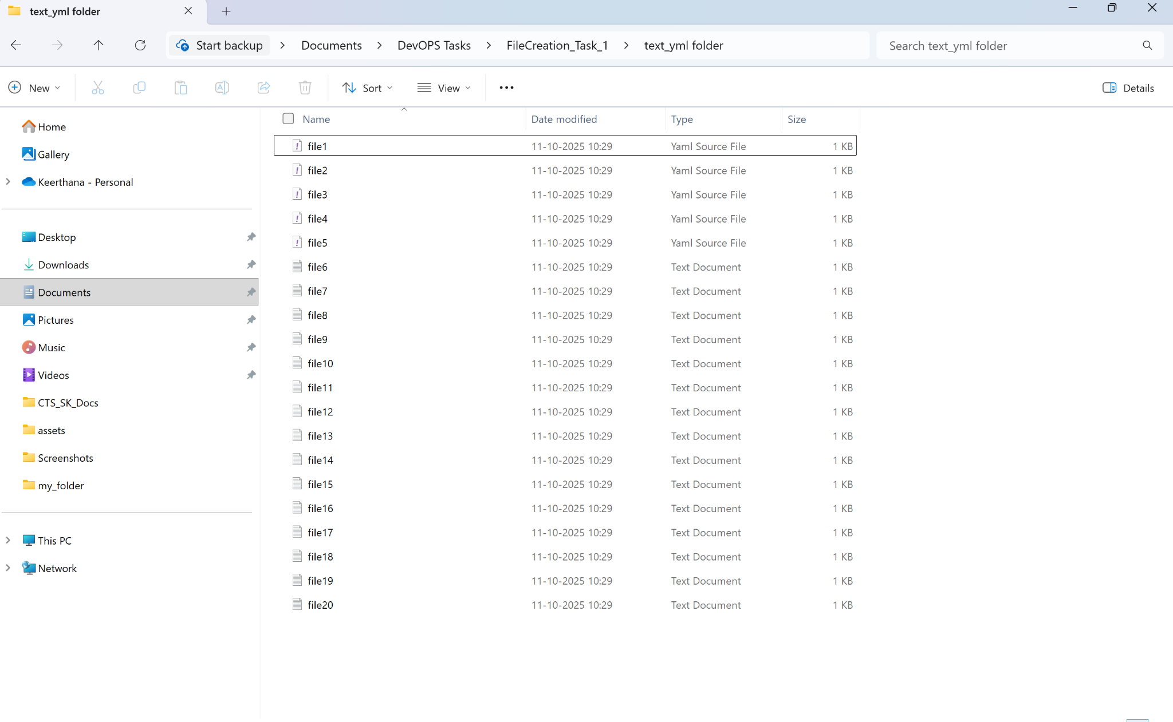

**Step 3 :** Print the top 5 newest files (newest first) among all files in this directory

**CMD:**

echo "Top 5 newest files (newest first):"

ls -1t | head -n 5

